ASSIGNMENT 2
FINAL LAB TASKS BY OM 2280156
COURSE CC

LAB 2B

TASK 1: CREATE RESOURCE GROUP WITH TAG

Resource Group Creation with Cost Center Tag
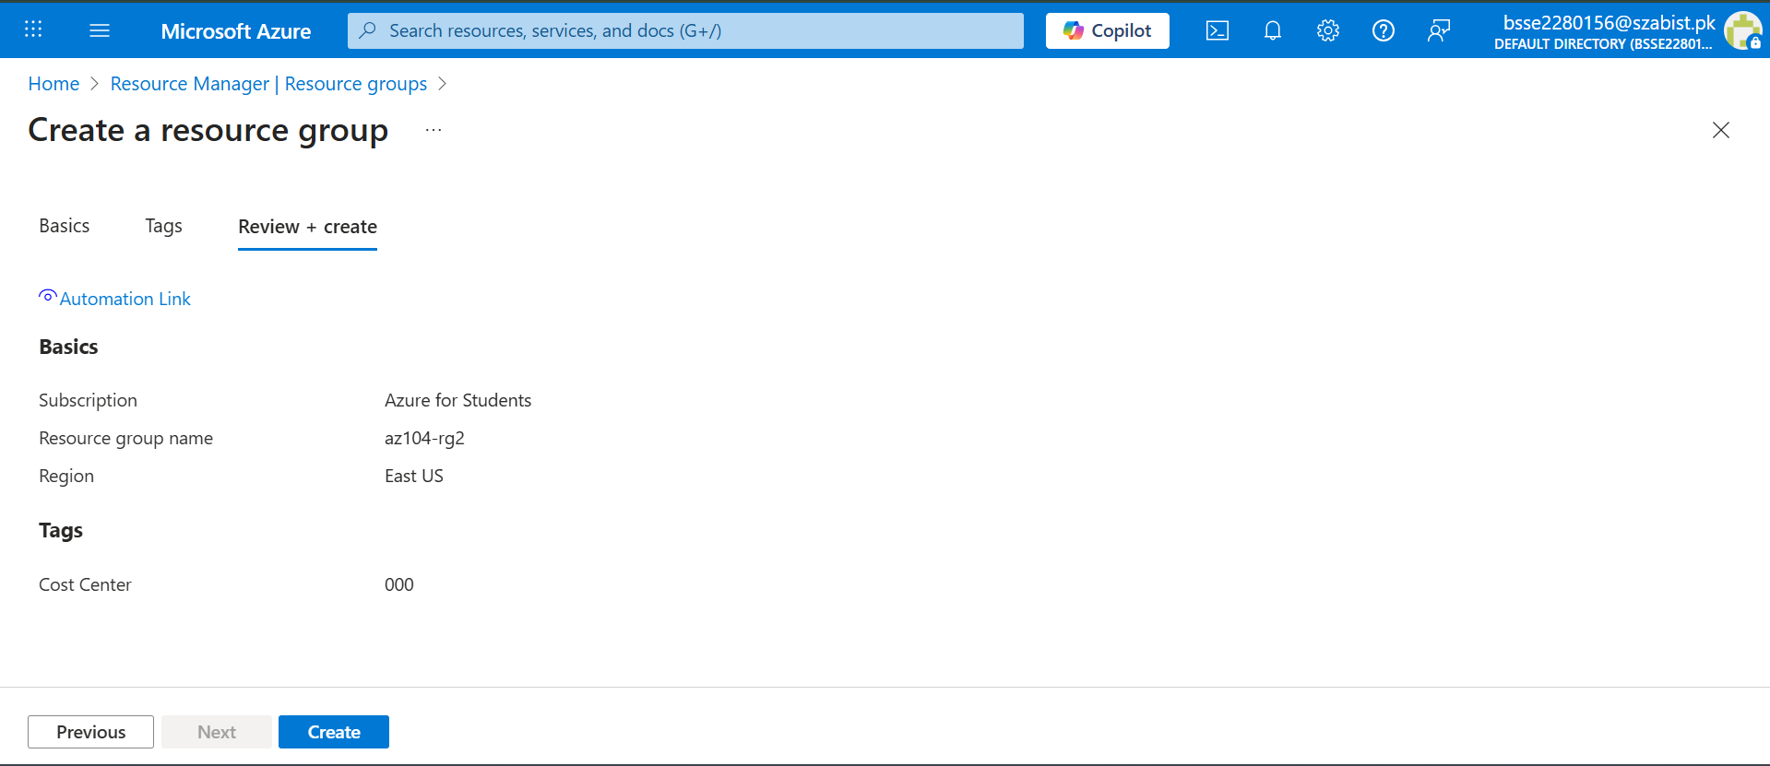

TASK 2: ENFORCE TAG USING AZURE POLICY

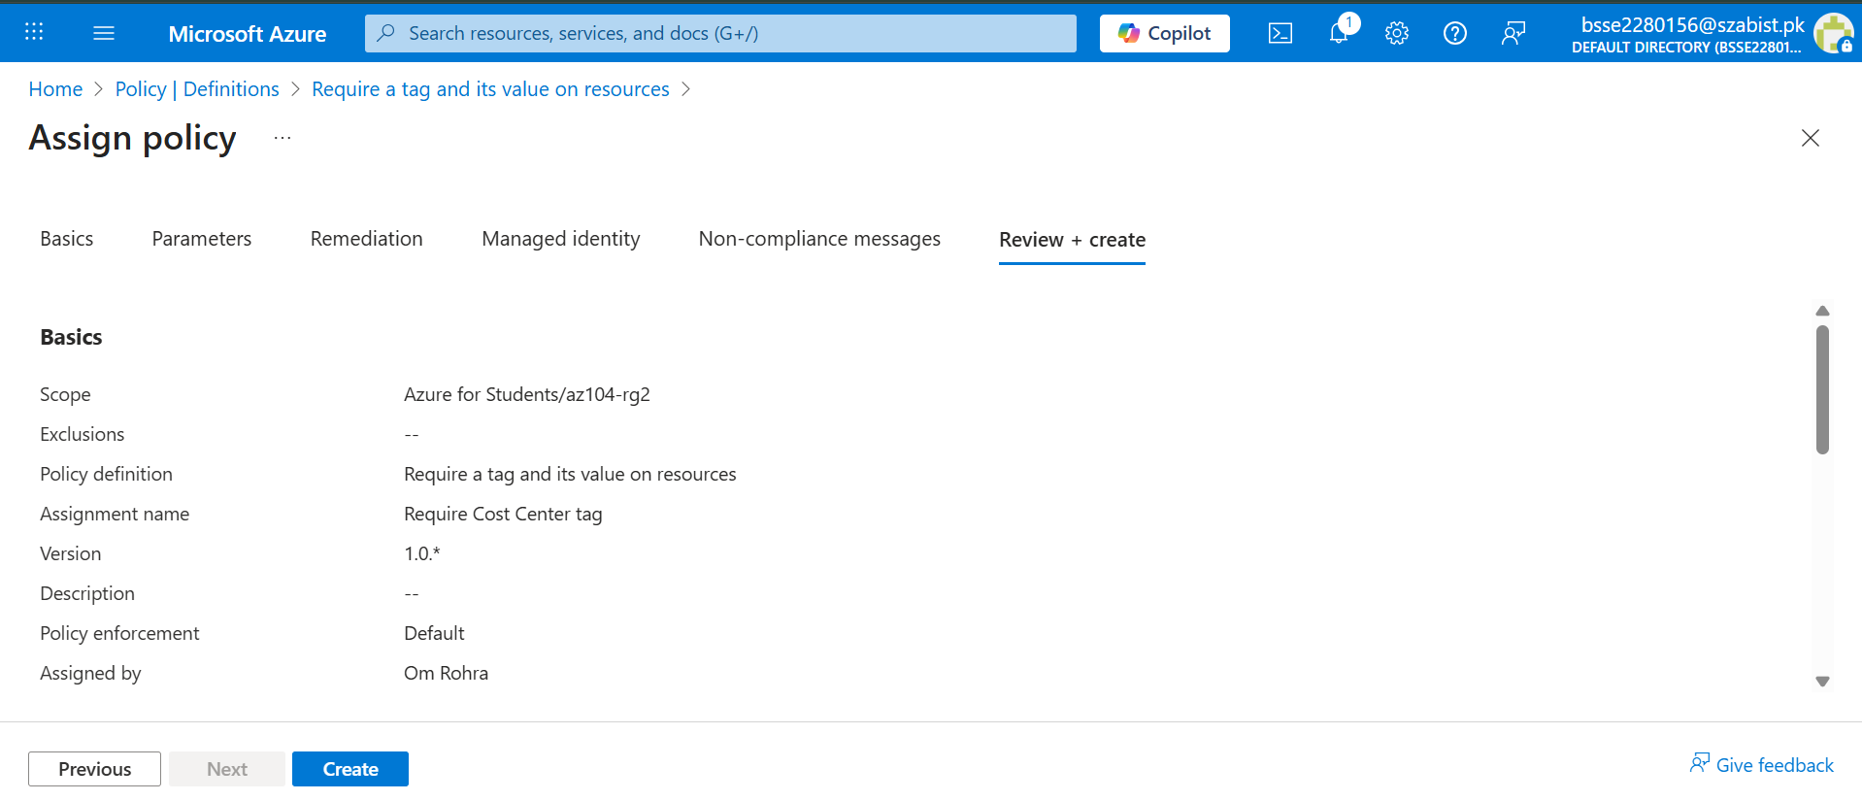
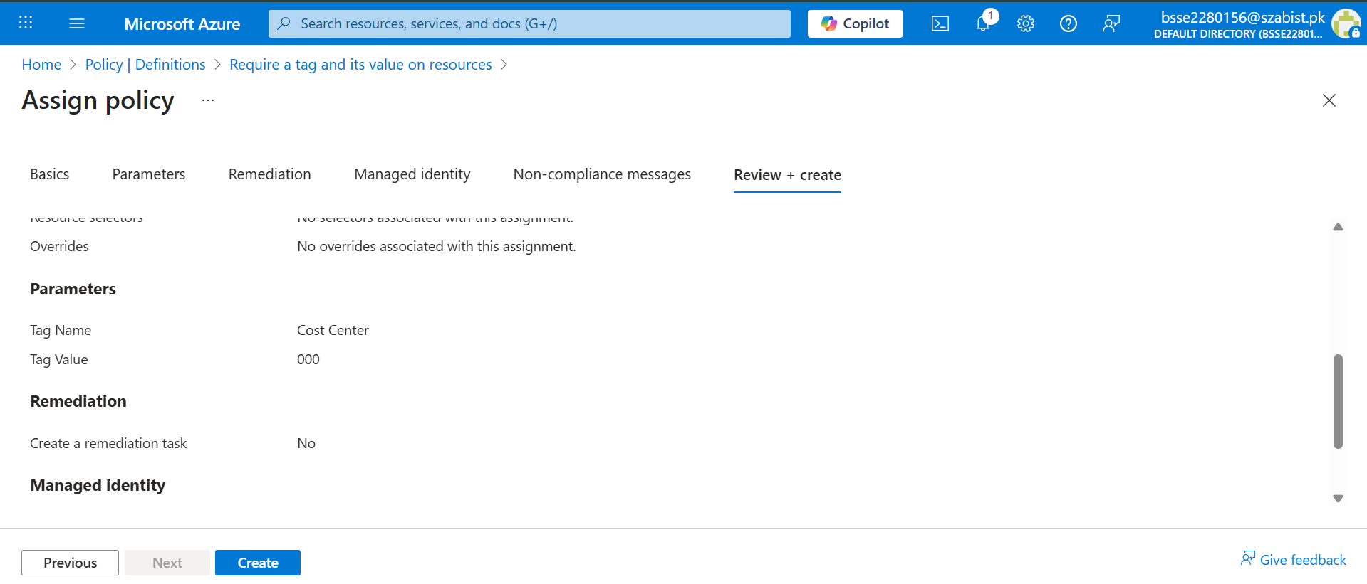

Policy Enforcement Blocking Non-Compliant Resource
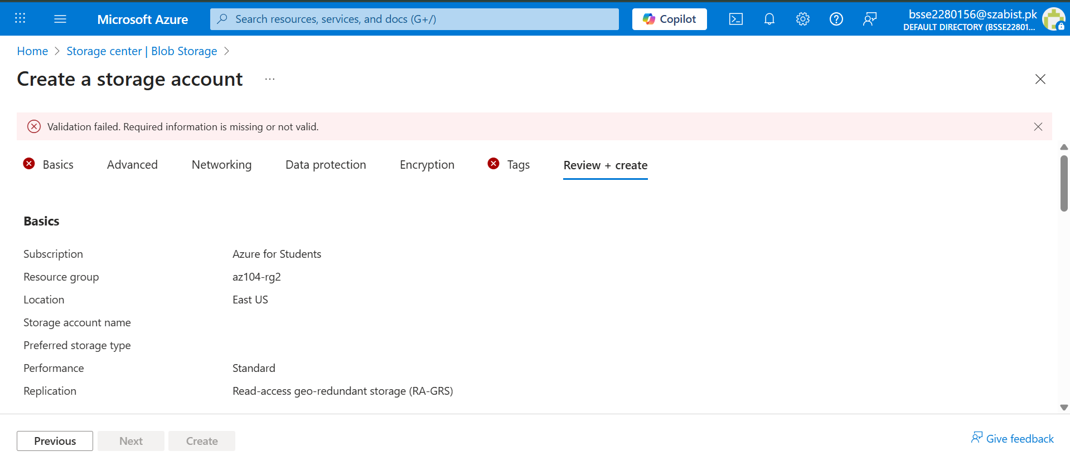

TASK 3: REMEDIATION USING POLICY

Azure Policy Remediation Configuration
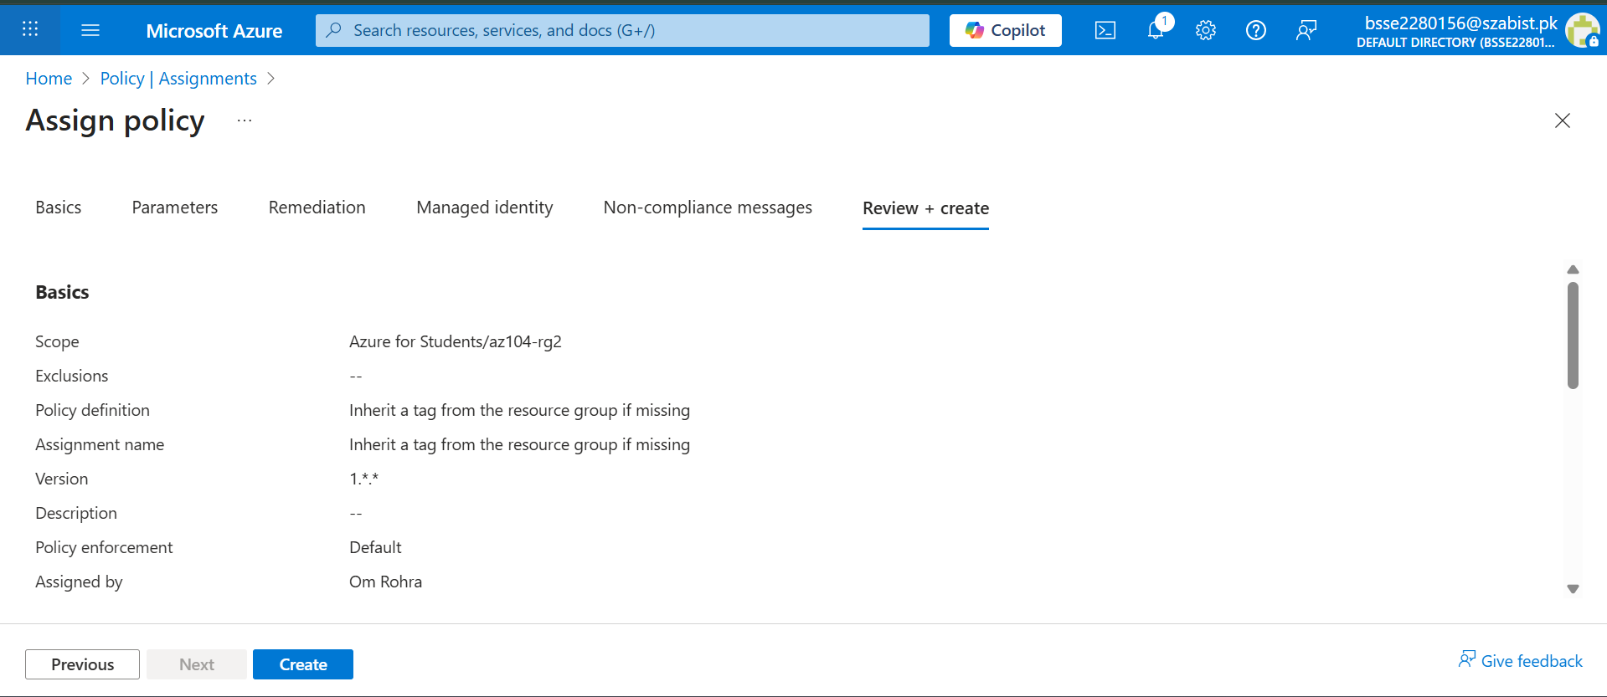
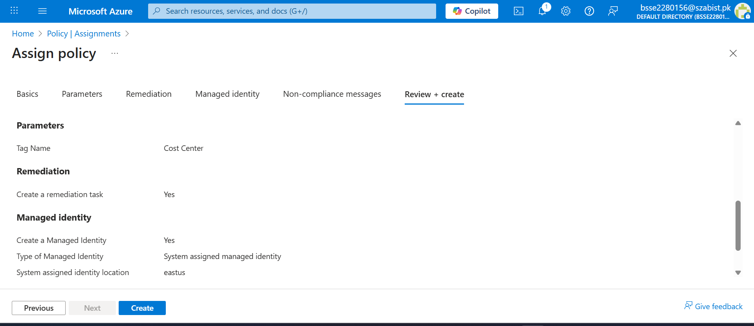
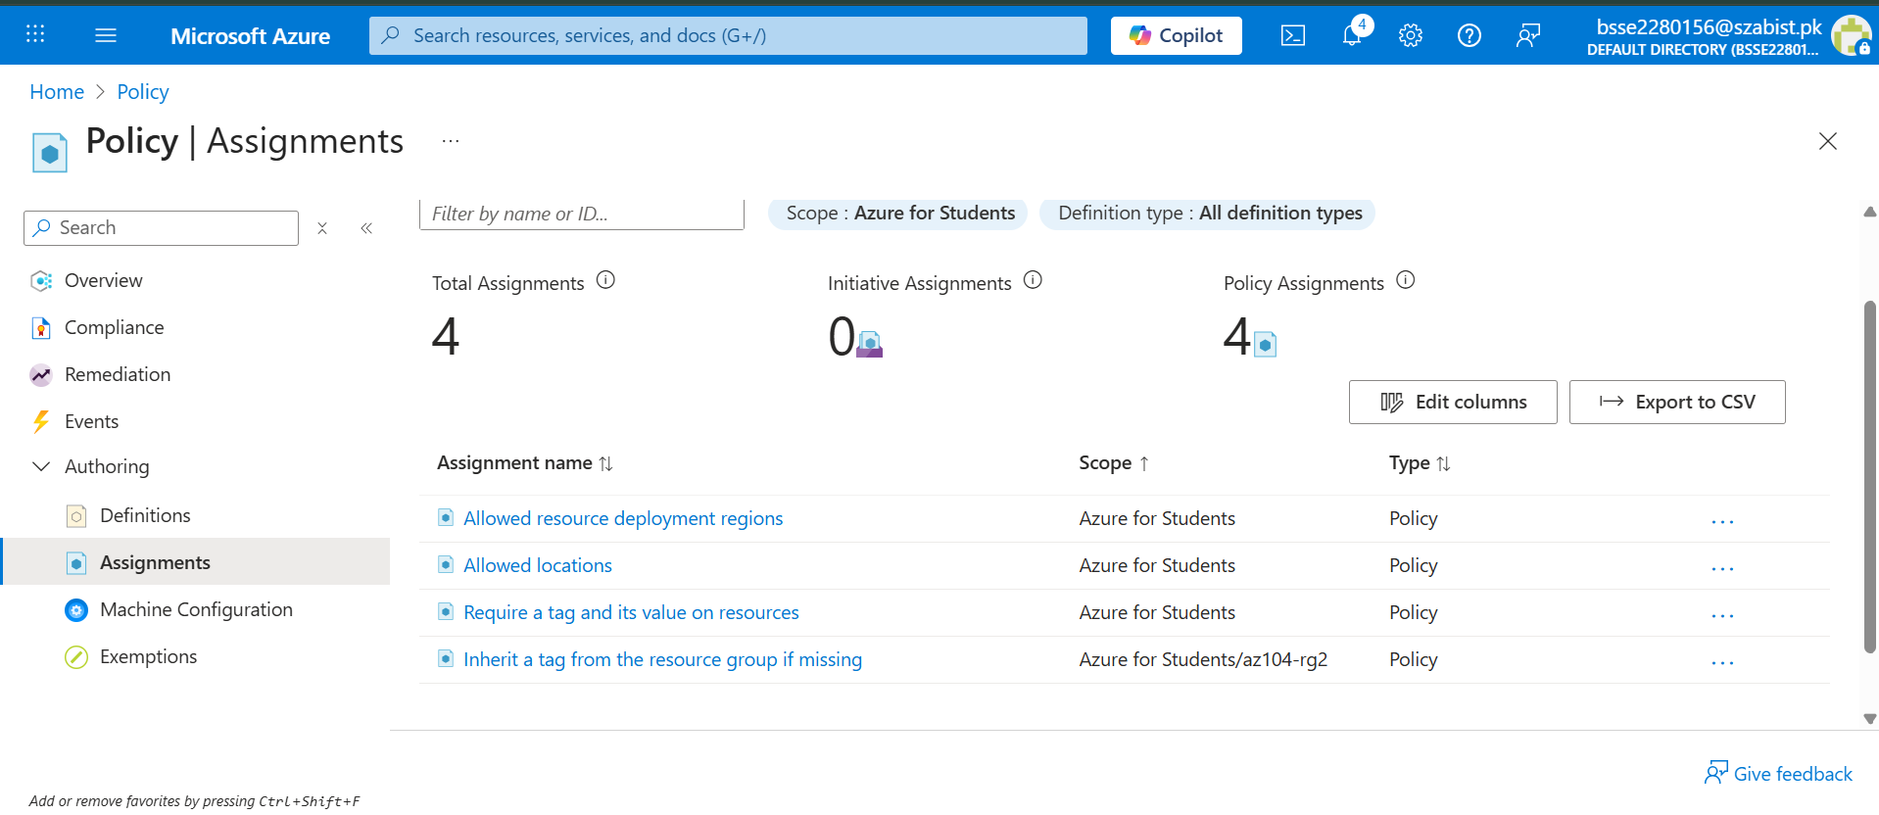

Azure Policy Blocking Resource Creation Without Required Tag
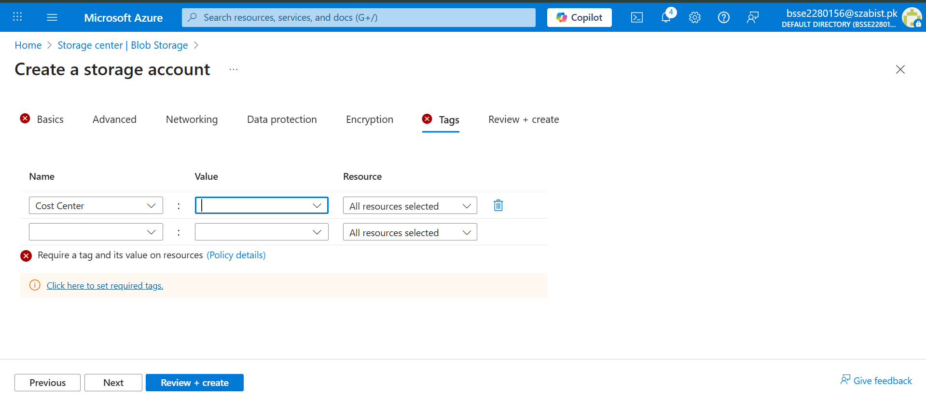

TASK 4: RESOURCE LOCK

Resource Lock Configuration
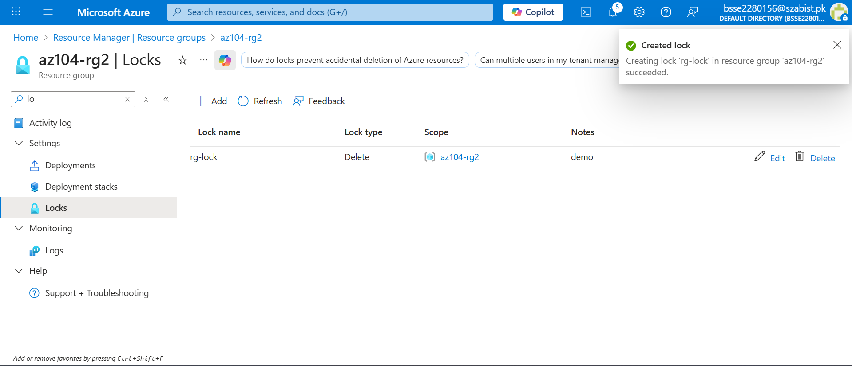

Resource Lock Preventing Deletion

Resource Lock Preventing Deletion

